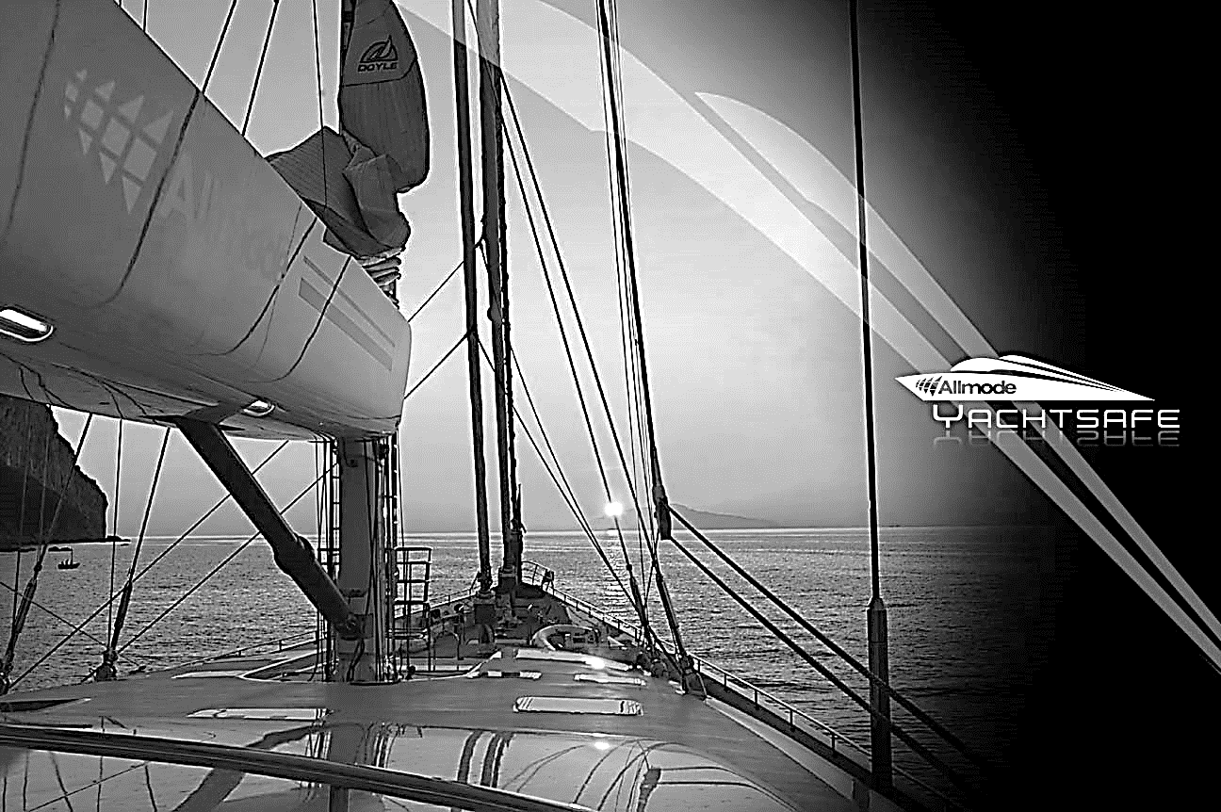

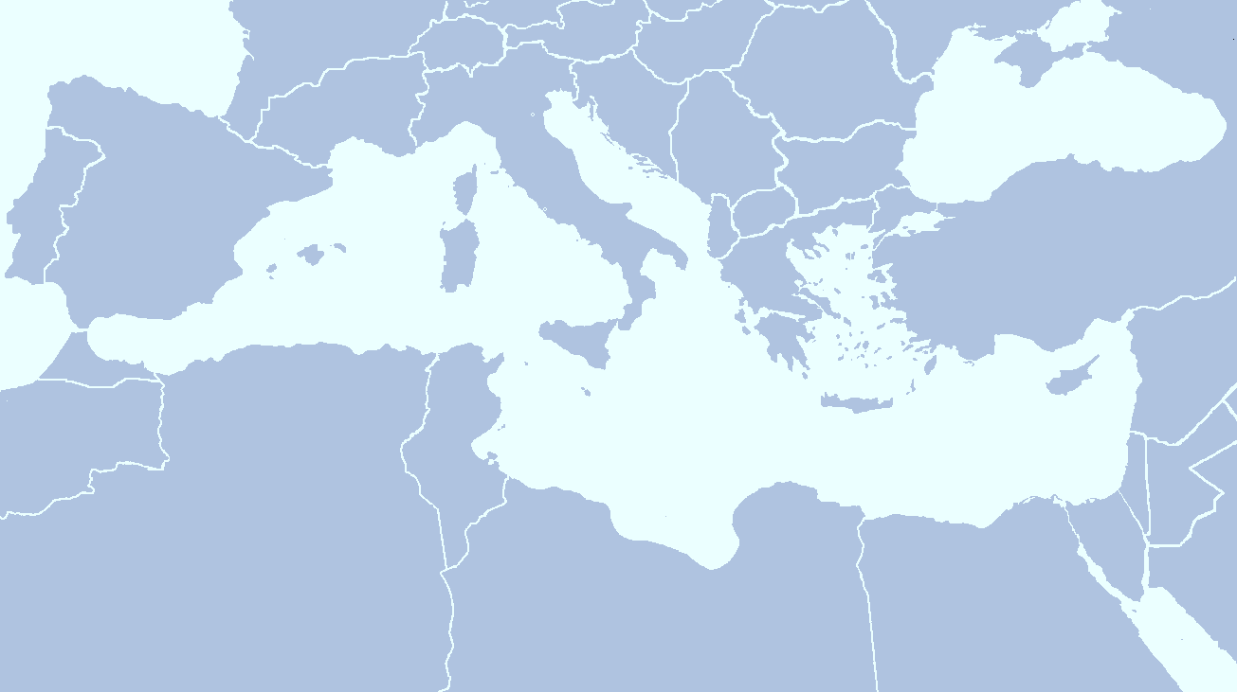

**Mediterranean Security Report**

3rd edition 2014:

Greece

Section 800 - Intelligence

Offices in UK | Dubai |China | Singapore

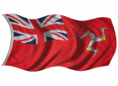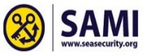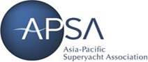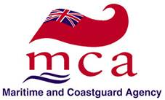

**Contents**

**The Mediterranean Report ……………………………………………….. Page 3**

**Greece and the Greek Islands Overview..…………………………………… Page 4**

**Climate ……………………………………………………………………………. Page 5**

**Greece and the Greek Islands**

* **Ionian Islands ………………………………………………………………. Page 6**
* **Argo Saronic Islands ………………………………………………………. Page 12**
* **Cyclades …………………………………………………………………. Page 17**
* **Aegean Islands……………………………………………………………….. Page 18**
* **Sporades …………………………………………………………………. Page 20**
* **Dodecanese …………………………………………………………………… Page 21**

**Crime Overview …………………………………………………………………… Page 25**

**Arrival / Departure Procedures ………………………………………………. Page 27**

**Health Advisory** **…………………………………………………………………. Page 30**

**Allmode Summary and Advice ………………………………………………… Page 31**

**Security Awareness Training …………………………………………………. Page 32**

**About Allmode ……………………………………………………………….… Page 33**

**The Mediterranean Report**

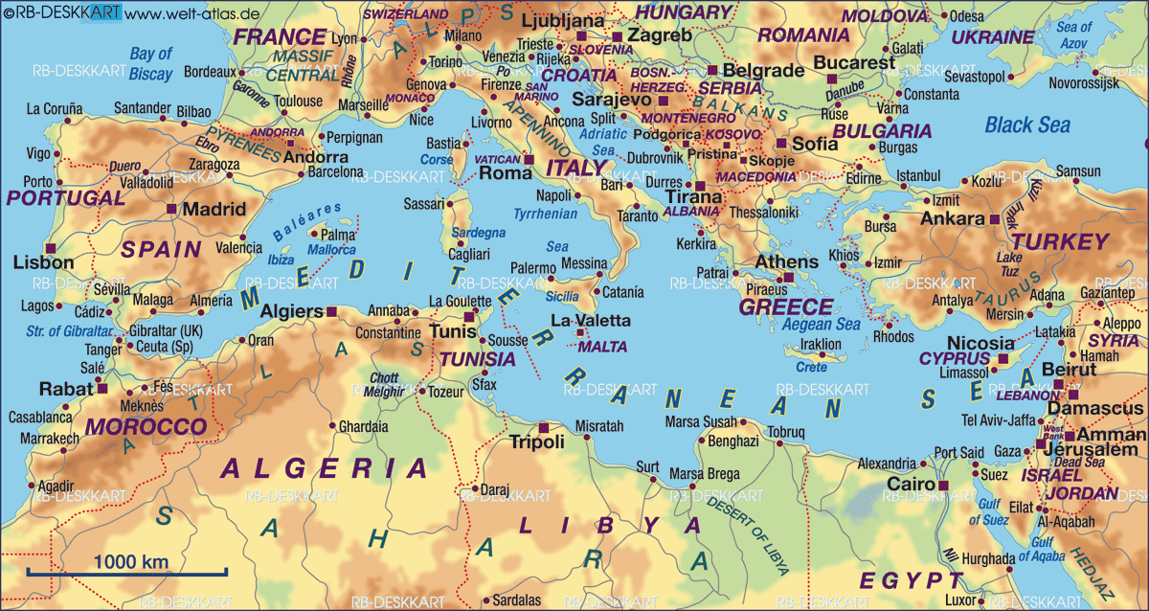

As the seasonal migration of the Super yachts begins from the winter cruising grounds of the Caribbean to the stunning shores of the Mediterranean, Allmode Intelligence will also be following the same route.

Over the summer months we will be issuing a number of ‘Mediterranean Security Reports’ which will outline security based information on different locations across the Mediterranean. The purpose of these reports are to aid vessels and their crews with up to date information that will help them build better knowledge of an area and thus improve their situational awareness.

Situational Awareness (SA) is all about having the information you need to make effective decisions. There will always be occasions when people are required to make critical choices – sometimes at a fast pace – and the vast majority of errors that can occur are as a direct result of failure in situational awareness.

For the majority of vessels and crew visiting the Med, it will be a very familiar sight, however for some it may be their first time and often, as with many locations across the globe, looks can be deceiving and can lull people into a false sense of security.

Intelligence is more than information and news gathering. It is the process by which information is collated, verified, analysed and used to respond effectively to time critical information. Current, historical and creditable intelligence not only tells you what the risks are but projects possible hot spots of criminal activity.

At Allmode we do not outsource intelligence but gain real time situational awareness and speed of reporting by continually developing our product, and getting the time critical information out to our teams and clients. These reports will look into areas such as crime, corruption and political issues within certain areas and offer advice on how to stay safe and in some cases advice on areas to avoid. It will also offer advice on any relevant health advisories to be aware of and travel information for those wishing to travel and tour certain areas or regions.

**Greece and the Greek Islands**

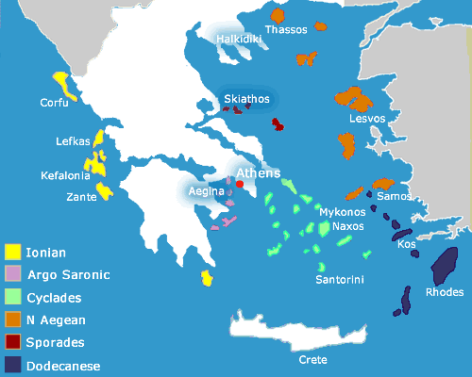

The Greek Islands comprise more than 6,000 islands and islets covering much of the eastern Mediterranean. Only about 230 Greek islands are inhabited and, of these, just 80 or so have more than 100 permanent inhabitants.

The Greek islands are traditionally grouped into six major clusters: (see accompanying map)

* **Ionian**: Found off the north-west coast of mainland Greece in the Ionian Sea these contain the popular holiday islands of Corfu, Kefalonia and Zante.
* **Saronic**: These lie in the Saronic gulf near Athens and the main islands here are Aegina and Poros.
* **Cyclades**: A large, dense group of islands in the central Aegean Sea that include the popular holiday islands of Mykonos and Santorini.
* **North Aegean**: A loose island group to the north-east of Greece. The main holiday destinations here are Thassos, Lesvos and Samos.
* **Sporades**: A small, tightly-knit island group just off the east coast of Greece that include Skiathos and Skopelos.
* **Dodecanese**: A long and loose string of islands that roughly follow the Turkish coast and include the popular holiday beaches on Kos and Rhodes.

Each island group has its own characteristics and each island within a group has its own character. The Ionian, for example are characterised by lush greenery, the Cyclades are 'typical' Greek islands of whitewashed cube houses on windy, rocky outcrops; the Dodecanese, close to the Turkish mainland, are the hottest, particularly in the south.

The popular destinations in the Aegean can be quite crowded in the summer months, whilst there are still the smaller islands that are frequented by yachts, which are quiet and unspoilt.

Extensive development of marinas both on the mainland and on the many islands, have encouraged the yachting market to expand. (See marina section below) Most of the new marinas are on the mainland and this is where you would find the best repair facilities. Haul-out facilities are available at Alimos, Aretsou, Flisvos, Glifada, Mandraki, Lavrion, Patras, Porto Carras and Zea. Marine equipment is readily available in and around Athens, but may be difficult to acquire elsewhere in Greece. It would be advisable to carry essential spares and have a full tank of water before leaving the Athens-Piraeus area.

The sailing season lasts from March until October, although the best time to go is heavily influenced on where you want to go. The most busy and popular time is between the months of July and September.

Unfortunately, this is the same time when the *meltemi* is at its most forceful and sailing Greek islands can become a little more challenging, although it does not affect sailing in the Ionian Sea. The summer winds in the Ionian is a light to moderate north-westerly that arrives in the afternoon and is usually dissipated by sunset; it is known as 'the *maïstros'.*

**Climate**

Spring and autumn weather is the most pleasant, while the summer is hot and dry.

Winters are mild in Crete and Rhodes and cooler as you moves north as well as inland.

The prevailing winds of summer are northerly. The seasonal wind of summer, called *etesian* in Greece because of its seasonal character, but better known by its Turkish name *meltemi,* sets in about May and lasts until September. It blows at its strongest in July and August when it can reach force 7 and even 8 on occasions. Violent storms occur only in winter, February being a particularly bad month, but overall the weather is pleasant and extreme conditions are rarely known.

Winds of force 10 are not uncommon in the winter months. Violent thunderstorms are also probable by late October to early May. The southern winter winds are particularly treacherous and unpredictable

There are therefore two distinct seasons; hot and dry between April and September, and mild and wet from October to March. Spring and autumn are short seasons of transition from winter rain to summer heat and sun, when the weather may be very changeable from day to day.

However, Greece displays very varying weather patterns depending on topograghy and geography, so it is best to look specifically at the forecast for the island and locations that you are visiting specifically.

The chart below gives an indication of the average weather conditions for Athens.

**Ionian Islands**

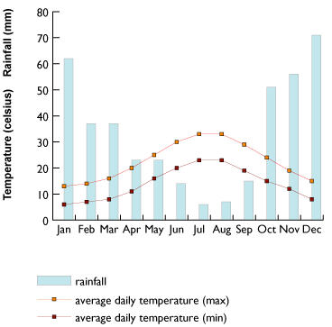

At only 30 km from the mainland, the Ionian islands runs along the west coast of Greece, with the main islands of Corfu, Lefkas, Kefalonia and Zante. With the historical links with both the Venetians and the British, the island is heavily influenced by both cultures in both architecture and culture. Visitors from Britain and Italy are the main tourists for the islands and the package type holiday makers will stick to the easily accessible beaches on the east coasts of the islands. The west coast of the islands tend to be more rugged and mountainous, making access to the best beaches much more difficult, unless you access via the sea. Links between the island are not as regular as the Cyclades, but it is possible to travel between them, even if the ferry services are only once a week.

The island of Kythira (including its satellite Antikythira) dangles off the southern tip of the Peloponnese between the Ionian and Aegean Seas. Historically, Kythira is considered part of the Ionian Islands, and today is administered from Piraeus. Though, due to its location and suitable ferry connections, visitors are most likely to visit Kythira from the Peloponnese

**Marinas in the Ionian Islands:**

* **Agostoli Marina Greece, Greek Ionian Sea**

**38˚ 10.8' N 20˚ 29.6' E**

|  |
| --- |
| Address |
| Cephalonia-JÃ³nico Norte  Greece |
| Berths : 250 Draught Max : 3.5 metres Dressing Rooms : Yes Length Max : 30 metres VHF : Chn 9 |

This is a new marina situated opposite the the town of Argostolion

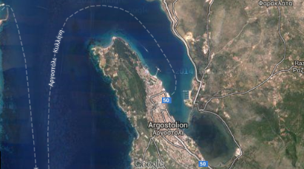

* **Cleopatra Marina Preveza Greece, Greek Ionian Sea**

**38˚ 57.5' N 20˚ 45.3' E**

|  |
| --- |
| Address |
| Aktio, Preveza  48 100 Greece |
| Contact |
| 0030 26820 23015 [clmarina@otenet.gr](mailto:clmarina@otenet.gr) [www.cleopatra-marina.gr/](http://www.cleopatra-marina.gr/) |
| Bars/Cafe/Restaurants : Quayside Berths : 100 Bottle Gas : Yes Chandlery : Yes Draught Max : 8 metres Drinking Water : On all pontoons Electricity : On all pontoons Length Max : 30 metres Travel lift : 300 Tonne TV Internet : Wi-Fi VHF : Chn 67 |
|  |

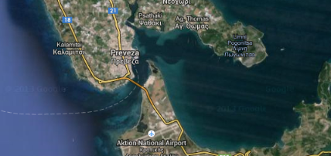

* **Gouvia Marina Corfu Greece, Greek Ionian Sea**

**39˚ 39.0' N 19˚ 51.1' E**

|  |
| --- |
| Address |
| P.O. BOX 6048083 Tzavros Corfu Greece |
| Contact |
| 0030 26610 91900 [k.g@medmarinas.com](mailto:k.g@medmarinas.com) [www.medmarinas.com/MarinaDisplay.asp?ITMID=44](http://www.medmarinas.com/MarinaDisplay.asp?ITMID=44) |
| Banks/Post Office : ATM at Reception office Bars/Cafe/Restaurants : Quayside Berths : 1235 BoatYard : Yes Draught Max : 5.5 metres Drinking Water : On all pontoons Electricity : On all pontoons Length Max : 80 metres Showers/Laundrette : Yes/Yes Travel lift : 65 Tonne TV Internet : Wi-Fi VHF : Chn 69 Weather Info : Daily |

Gouvia Marina in Greece, is situated about 6 kilometres from the town of Corfu and 7 kilometres from the International Airport. For many years seamen considered the harbour and the bay of Gouvia as a natural link between the Adriatic and the Mediterranean Sea as well as a port of call, where they could sail in, to repose, enjoying the climate and the beauties of the island.

The Marina, fully organised, offering facilities and services of high standards, has been operating under the new management since 1996. The total capacity is 1100 berths, on both permanent and floating pontoons, while there are dry dock facilities for approximately 520 boats. Moorings are available for boats up to 80 meters long and with 5.5 meters draught, for short or long term periods.

In the marina you can find a supermarket and a chandlery shop covering most of your essential requirements as well as a diving equipment shop. Restaurants, bars and cafes are located in the quayside. You can also enjoy a swim in the swimming pool while there is also a kindergarden, a cricket and a croquet field.

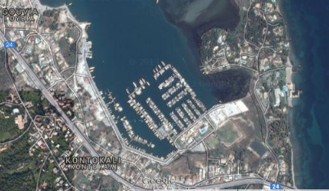

* **Lefkas Marina Greece, Greek Ionian Sea**

**38˚ 49.9' N 20˚ 42.8' E**

|  |
| --- |
| Address |
| East Shore Lefkada 31100 Greece |
| Contact |
| 0030 26450 26645/26646 [k.g@medmarinas.com](mailto:k.g@medmarinas.com) [www.medmarinas.com](http://www.medmarinas.com/) |
| Banks/Post Office : In the town Bars/Cafe/Restaurants : In Marina & the Town Berths : 630 BoatYard : Yes Chandlery : Yes Draught Max : 4 metres Drinking Water : Yes Electricity : Yes Fuel : Fuel berth VHF Ch 9 Length Max : 40 metres Showers/Laundrette : Yes/Yes Travel lift : 70 Tonne VHF : Ch 69 |

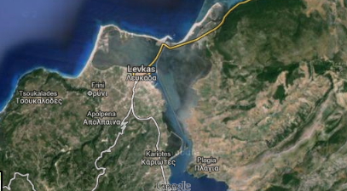

* **Odyseas Marina, Greek Ionian Sea**

|  |
| --- |
| Address |
| Vathy Bay Meganisi 31083 Greece |
| Contact |
| Ioannis Andriotis 0030 26450 51084 [welcome@odyseasmarina.com](mailto:welcome@odyseasmarina.com) [www.odyseasmarina.com](http://www.odyseasmarina.com/) |
| Banks/Post Office : Post Office Bars/Cafe/Restaurants : Gimlet Cocktail Bar in the marina, many other bars and restaurants within walking distance Berths : 68 Bottle Gas : Yes Buses/Taxis : Buses and taxis Chandlery : Yes Draught Max : 8 metres Dressing Rooms : Yes Drinking Water : Yes in berth Electricity : Yes in berth Fuel : Yes in berth Gas Station : Yes Length Max : 60 metres Max Depth (M) : 8 metres Medical Services : Yes on the island Moorings : Laid moorings Showers/Laundrette : Yes/Yes TV Internet : Nova television in the bar VHF : 72 Water : Yes Weather Info : Daily in marina office window |

Odyseas Marina (Greek for Ulysses) is a premier marina facility for yachts within the Ionian Sea – it is a wonderful lifestyle destination that has adopted the location's magical surrounding into the yachting facilities designed for exclusive guests. This luxury marine facility is the pristine setting to live the ultimate yachting experience. The marine meticulously presents a complete range of amenities and services. The Marina on Meganisi Island is designed to satisfy most of your yachting needs in one location, offering hi-tech amenities designed to pamper you, as well as your yacht.

The newly built Marina has 68 berths where you can indulge in the ease of hi-speed in-slip fuelling, black water pump-out and waste oil removal, up to 64 amps of 3 phase power, concrete docks and 24 hour surveillance equipment that you can access from a laptop anywhere - anytime in the world (currently installing 12 hi-definition cameras with night vision to check the weather, the docks, and the boats). Additionally, there is the convenience of on-site repairs and services, in- slip hi-speed communications, comprehensive nautical provisioning, including gourmet food & wine, catering, laundry, florist and ships' chandlery, as well as an onsite tennis court and basketball court.

**The Entrance**

The marina entrance and area in Vathy is signalled with 2 lighthouses which have flashing green lights when it's dark. The first is located on the breakwater in the marina and entrance to the bay and the other separates the town quay from the marina.

The marina has 68 laid moorings with in berth water and electricity supply. We can accommodate mega yachts up to 60m with a draft of 8m and an electricity supply up to 63Ah.

**Formalities**

On arrival into the area of the marina, contact the harbour master on VHF channel 72 and they will assist you in berthing. Pre-booking berths 1 or 2 days prior is recommended during the busy summer months, this allows you to enjoy and make the most of your day sailing or relaxing, coming in later in the afternoon.

* **Argostoli (Argostólion, Kefalonia.)**

**38° 10’N - 20° 29’E**

This marina includes a range of services available to its customers. The marina can also provide its customers nautical services which may be of use.

In addition to coming by boat, you can also reach the marina by air, given the short distance between the marina and the nearest airport.

* **Port Zakinthos, Zante.**

**37° 46’N - 20° 54’E**

The marina Port Zakinthos is located in Zákynthos (Greece). All guests who moor there will have access to very basic services, such as water, electricity and gas station. Its users may take advantage of its complete basic range of services. . If you are looking for a port with nautical services, Port Zakinthos has some available.

In addition to coming by boat, you can also reach the marina by air, given the short distance between the marina and the nearest airport.

**Argo Saronic Islands**

The Saronic Islands are dotted in the great seas south of Athens

The Saronic Islands include just four main islands: Salamis, Aegina, Poros and Angistri.

Considered the most ‘balanced’ of any sailing ground in Greece, the Saronics offer a fantastic mix of great sailing winds, short-hop sailing, diverse islands, character harbours, archaeological treasures and quayside bars and tavernas.

The nearest to Athens is **Salamis** and the close proximity to Athens virtually makes it just another suburb of the capital.

Nearby, **Angistri** is a short one hour journey by hydrofoil from Piraeus and is used as a holiday island by many Athenians. This can get busy in the summer months, but it is always possible to find a quiet spot. So too is **Aegina.**

**Poros** is positioned across the water from the Peloponnese, which is just a few kilometres away. In Poros town the large ferries dock at the western end of the town's long harbour front, whilst smaller boats go back and forth between the island and the mainland town of Galatas.

**Spetses** is a place where you can relax; it is a small island and close to Athens, which of course means it is quite well-connected in terms of ferries, so you'll not face too many difficulties in actually getting to this particular Saronic Gulf Island. Although small, the island is busy enough to keep you entertained for at least a week or two.  
  
The port in particular, is very attractive and very picturesque.The one special thing about Spetses is there are no cars, only carriages and bikes for transport.

**Hydra** is the busiest of the Saronic islands and has a mix of visitors, from charter holiday tourists, Athenians, wealthy yacht owners and cruise ship passengers. Prices reflect this. An attractive feature of the town is the absence of prolific scooters and hell-raising motorbikes found in most other island capital towns.  The island does have motorised transport, but it is restricted to council services transport such as sanitation and construction. For the tourist, donkeys and mules are the main means of transport.

**Kythira** is perhaps one of the last unspoilt, large Greek islands and is isolated from all other island groups.  Unfortunately, the fact that it is so remote presents problems as a consequence. One major issue is that it has very few ferry connections. So, the number of visitors who travel to the island is lower than the number of visitors who go to other islands.

The tiny island of **Antikythira** which lies just 38 km (24 miles) southeast of Kythira with a population of just 20 people (approximately), is the most remote island in the group.

Weather - While the predominant wind in the Saronic comes from the northeast, the Meltemi (the strong, dry north wind from the Aegean Sea) is present in the Saronic Islands. The Meltemi can pick up to 5-6 Beaufort, particularly later in the season around July and August, but the winds usually calm down later in September. In the Argolic Gulf around Hydra and Spetses the wind blows mainly from the southeast, though the Meltemi also affects this area, bringing some fantastic afternoon sailing breezes.  
  
With temperatures averaging between 22 and 25 degrees in May and October it makes it a great destination to visit out of peak season.  In July and August expect temperatures of 28 to 33 degrees.

**Marinas in the Saronic Islands:**

**Lavrion - Olympic Marina**

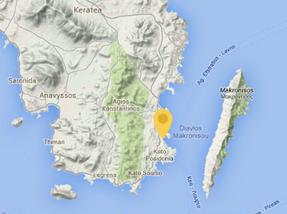5M N of Sounion. A large marina for yachts of 30m or more, with draughts of up to 10m; good access and shelter.  
  
680 berths, repair unit, 700 places on dry dock, travel lifts 45t, 65t, 200t, experienced personnel for any kind of maintenance, repair teams of your choice and 24 hours surveillance of private security company.

Marina rewarded with the "Blue Flag" since 2000 and ISO 9001:2008.

Facilities: travel hoists up to 200 tons; water and electricity on pontoons and fuel berth; good provisioning.  
  
A secure place to leave a boat but at the time of writing rather run down; 30M from Athens but airport only 15M. The last major refuelling stop.

Sounio-Athens-Greece  
77th Athinon-Souniou  
Tel.: +30 22920 63 700  
Fax: +30 22920 22 569  
V.H.F Channel 9

**Athens Marina -**  located only 9 km from the centre of Athens.

Lat : 37° 56.290' N  
Long : 23° 39.928' E  
VHF Channel : 9  
Call Sign : Athens Marina  
Tel : +30 210 4853200  
Fax : +30 210 4853300  
Email : [info@athens-marina.gr](mailto:info@athens-marina.gr)

**Athens Marina** is designed to cater to the mooring needs ofmega and super yachts.  
  
The marina has a mooring capacity of 130 yachts and can accommodate yachts up to 130m, with over 10 berths for mega yachts of 50m up to 100m and over 25 new berths for super yachts of 30m to 35m.

**Athens Marina** has a large seafront entrance for easy access, along with tender pilot assistance and a unique dock for alongside berthing, which can accommodate yachts up to 130m.

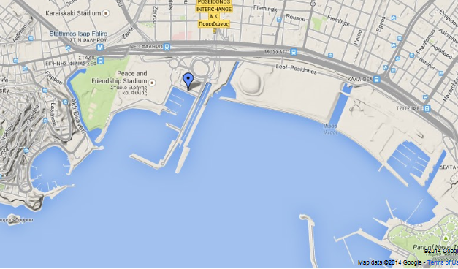

**New for the Summer 2014 Season - Ermioni 'super-yacht' Marina**

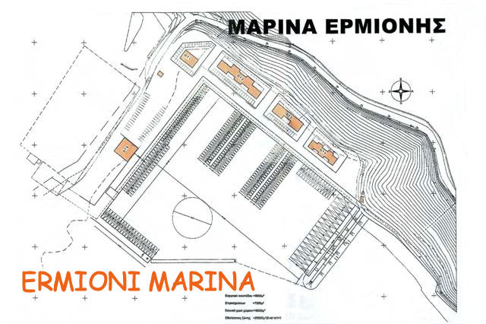This super marina should be operational by Spring 2016, so far, the designated area has only been fenced off.  Located at the Limani outer harbour, opposite the Ermioni football ground and alongside the road leading up to the church of Aghios Gerasimos and the Milos Cafe bar.  Operated by the marina specialists, Camper & Nicholsons, this exclusive marina will be their first in Greece and includes the accommodation of more than 127 yachts, up to 65m in length.  This complex will house bars, restaurants and shops.  In addition, there will be a swimming pool and chandlery.  This newly planned marina will also provide a much needed 5-star facility for the existing prospective property owners within the Ermionida region, giving yacht owners a secure place to berth their yachts.  Visiting smaller yachts and flotillas will also have numerous places to anchor within the inner harbour of Limani, or, on the Southern side of the peninsula, along the Mandrakia harbour front.  This new marina is well placed for the extensive cruising waters of the Eastern Mediterranean.

**Aigina Marina –** usually a first or last stop-off before Athens.

The marina Aigina Marina is located in Piraeus (Greece) All guests who moor there will have access to very basic services, such as water and electricity. Its users may take advantage of its highly varied basic range of services. . The marina can also provide its customers nautical services which may be of use:

Draught max: 6.00 meters  
Services:  
Harbour Master's Office  
Drinkable water  
Electricity  
Showers  
Toilets  
Supermarket  
Bar / Restaurant  
Bank

The harbour of the island is the Aegina town which is at the North-Western end of the island.

There are mooring places in Aegina town and in Perdika. For anchorages in Aegina, you may go to Ag. Marina, Mourioti bay, Klima, Ligia bay and Kipos.

**Poros Marina** –

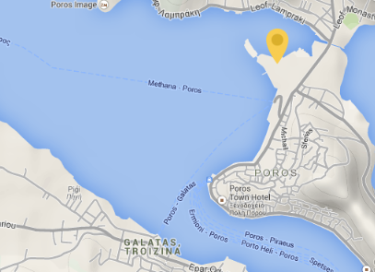The main harbour is at the north side of Poros. Recently, new piers added to increase the capacity. It is a safe shelter for all winds. Yachts can moor to the quay on the old docks of the North side of the town as well as on the South in the narrow channel.

18020 Poros

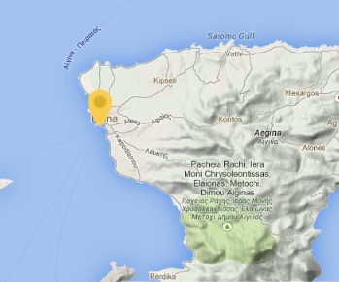VHF Channel: 12  
Port Police Tel. No: +30 22980 22 274  
Health Centre Tel. No: +30 22980 42 222  
Chart: Imray Tetra G14 & G141

Anchorages in Poros, highly suggested ones are, Ormos (bay) Vidhi, cape Dana, Russian bay, Neorion, Alyki, Monastery bay & Soupia islet.

**Hydra Harbour** – extremely crowded in the summer months.

Draught max: 6.50 metres  
Services:  
Drinkable water  
Showers  
Toilets  
Supermarket  
Bar / Restaurant

The port is at north coast of island, and very safe shelter. This small port of Hydra is almost always full of small and bigger yachts during summertime.

It is possible to find that yachts are berthed second and even third row from the quay. Anchoring into harbour is an another alternative. Yachts can moor to the town quay or to the N mole (when available). NOTE: In case of N-NW strong winds, the only safe shelter for yachts is on the N mole.

Anchorages in Hydra island: Vlihos, Ormos Molos, Petassi, Bisti, Saint Nikolaos.

Limín Ídhras Idra 180 40  
VHF channel 12  
Tel. Port Authority: +30 22980 52279  
Fax Port Authority: +30 22980 53912  
Medical Centre: +30 22980 52420  
Maps: British Admiralty Chart 180

**Spétsai (Baltiza Creek)-**

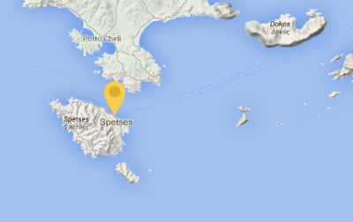Anchor in the bay with a long line ashore or stern or bows-to in the inner harbour if there is room. Bâltiza Creek is a popular destination for yachts in the season and the inner harbour will usually be full to bursting and the outer harbour too crowded for you to swing at anchor. In the outer harbour the bottom is sand and weed (poor holding in patches) and in the SW corner there is a large permanent mooring chain fouling the bottom. In the inner harbour the bottom is mud - excellent holding.

Shelter With strong NW winds the outer harbour is uncomfortable and possibly dangerous for small yachts. Wash from the water-taxis in the outer harbour can be uncomfortable though not usually dangerous. The inner harbour has excellent all-round protection and a number of yachts are wintered afloat here.   
Authorities Port police and customs in the new harbour. Charge band 2 in the inner harbour.

The old harbour, Baltiza is well sheltered. One can either moor in the inner part or drop anchor in the outer part of the harbour, Baltiza is usually crowded during summer, so it is suggested to try to moor before noon.

The new harbour Dapia is considered as the main harbour and reserved for the ferries & local boats.  
Highly Suggested Anchorages are Ormos Zoyioryia (NW of Spetses).

**Cyclades**

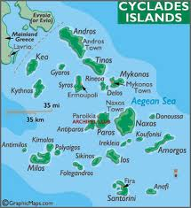The Cyclades lie to the south east of Athens and the Greek mainland and to the east/south east of Poros. From Poros you can sail due east across the eastern Saronic Gulf to Kéa (Kea) or Kíthnos (Kythnos), or head north east to the mainland and then run down the Attic coast. They are the picture perfect images of Greek islands. the Cyclades islands are not protected by any mainland. Their position out into the Aegean Sea means they are more exposed to the northerly ‘Meltemi’ wind which very much dominates the Cyclades islands, making sailing conditions more challenging. Winds can whip up from a force 4 to a 7 very quickly, so sailing is for those with experience or a sense of adventure.

**Kéa -** 37° 39’.90N 24° 18’.60E

Kéa is the north western-most of the Cyclades islands and the first island you will reach if you travel from the mainland Attic coast. The harbour at Vourkari gets particularly busyon Saturdays and Sundays, when Athenians descend on the island with their motor boats, so best avoided at these times.

**Mérikha on Kíthnos** - 37° 23’.60N 24° 23’.56E

The island of Kíthnos (Kythnos) lies just to the south of Kéa, famous for its cheese and Mérikha lies on the western side of the island and so is the most directly accessible harbour when crossing from Poros. Mérikha is worth a visit and is the principal port of the island.

**Loutrou on Kíthnos** - 37° 26’.53N 24° 25’.85E

Loutrou lies to the north east of the island of Kíthnos and is known for its hydropathic institute based around the local hot springs that in past times gave the island the name of Thermia. Like Mérikha, Loutrou is worth a visit.

**Livádhi on Seriphos** - 37° 07’.62N 24° 31’.54E

Sérifos (Seriphos) is the next island to the south of Kíthnos (Kythnos) and is recognisable by its domed shape. The main port of Sérifos is Livádhi (Livadhi) to the south east of the island and is at the head of a spectacular bay. The quay is often crowded, but anchoring near the beach is no problem although sometimes two ‘hooks’ are advisable.

**Kamarés on Sífnos** - 36° 59’.57N 24° 39’.66E

Sífnos lies just 9 miles to the south east of Sérifos across the Sífnos channel. The channel can often be ‘quite fresh’ as the north easterly wind funnels between the two islands.

Kamáres (Kamares) on the north western side of the island is the main ferry port of the island and lies at the head of a large bay providing good shelter.

**Vathí** (Vathi) sits on the northern side of a small circular bay on the south western side of Sífnos.

**Adhamas on Mílos** - 36° 44’.68N 24° 23’.76E

Mílos is an old volcano and therefore the bay is surrounded by cliffs of pumice and basalt and the island has numerous hot springs, all fed from the same underground source that once fed the volcano.

The main port of Adhamas (Adharas) is on the northern side of the caldera (Órmos Mílou) and provides an excellent point from which to explore the island. However the bay is open to the north west and so does not provide good protection from the *Meltemi* which blows down through the entrance causing a swell, particularly through the entrance itself.

**Aegean**

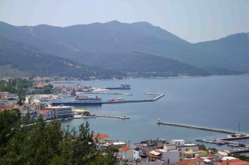The summer *meltemi* blows quite strongly through the spaced out islands that make up the north Aegean islands. The main islands (Thassos, Samothraki, Limnos, Lesvos, and Khios) are 40 to 50nm from each other. Each is quite large, and completely different from the others. There are enough interesting ports, pretty harbours, quiet anchorages and friendly people to make each island worth a visit while you’re sailing through. The northernmost islands are only lightly touched by tourism, and on these, many seasonal restaurants may be closed outside July and August.

**Thassos** is a popular resort island for visitors from the Balkan states; food here is cheap and cheerful. On the north of the island, seek out the classic sites (the agora and the acropolis) close to the Ancient Port in Thassos town. On the south of the island, don't miss Alyki, a well preserved old hamlet with good, if rather crowded, beaches.

**Port Neo Limani - Thassos**

The new harbour of Neo Limani is 500 meters west of the old harbour and is now the preferred harbour for visiting yachts, offering good all round shelter and depths of four meters plus. Yachts go alongside or - at busy periods - anchor moor to either of the two breakwaters. Hydrofoil ferries use the inner section of the north breakwater but their wash is not generally too disturbing. There were no electricity and water installations as at July 2008.

**Samothraki** has few visitors, and the only suitable port, Kamariotissia, is yacht friendly. It's worth taking a bus or taxi to visit the ruins of the Sanctuary of the Great Gods, about three miles NE, near the coast. Travel back through Hora, an attractive town.

**Limnos** has mainly Greek visitors in peak season, and a few thousand Greek soldiers and airmen protecting the island from Turkish invasion. Its strong points are a number of pleasant anchorages around the SW corner of the island (with the shore sides slowly being developed), and fine wines. The **port of entry,** Myrina, has a lot of character, with a nice mix of old mansions and small stone houses, all overlooked by a grand (flood-lit) castle. Moudros has very well sheltered berthing for yachts.

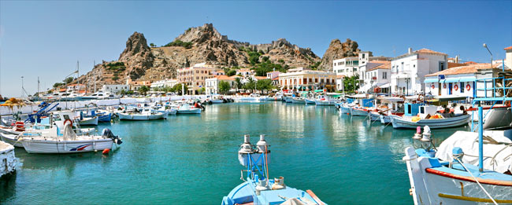**Lesvos.** There was a rush of tourism to Lesvos around the 1990s, probably because it has an **airfield** which accepts large passenger jets. The **port of entry**, Mytilini, is interesting, but scruffy and slightly seedy. A well sheltered marina started operating summer 2011.  Plomarion, to the south, is a more pleasant port, though subject to surge in strong northerlies. Molivos (Mythimna) on the north coast was often described as the prettiest village on the island, but now seems to have lost its heart to tourism. The anchorage in Sigri is peace and quiet. Inland is different, because quite large agricultural areas are inaccessible to motor transport, which leaves a lot of the island relying on donkeys to gather the harvests.

**Khios** is busy place, the town full of life. With 30,000 population, it supports a small university and a really lively market area. The effect of tourism is minimal, so prices are reasonable compared to neighbouring islands. Add to that several surrounding islets, plenty of anchorages for a day sails and this is a good spot to visit. There is an unmanaged marina just north of town, with a quite scary entrance guarded by a rocky reef.

**Nisos Oinoussa**, a group of tiny islands off the N corner of Khios, has some anchorages and the very well sheltered harbour at Mandraki. Moor end on to the quaysides.

**Samos** and **Ikaria** are dealt with as part of the Dodecanese, even though they aren't. They're a natural extension of a Dodecanese cruise area.

**Sporades**

**Evia -** Evia stretches nearly 100nm along the north east facing coast, east of Athens. It connects to the mainland by a bridge. The east coast of the island is inhospitable when the *meltemi* blows. The channel between Evia and the mainland is then convenient for making a passage north, offering flat water, though the *meltemi* does create some strong gusts. There are plenty of harbours in the channel. Strong tidal streams run through the narrows at Khalkis, where the sliding bridge joins Evia to the mainland. The bridge is opened for boat traffic only at night and at slack water. Lesser streams run along the north coast of Evia (up to 2.5kts). On the mainland at Angistri, a few km south of Khalkis, is a small family owned boatyard which has provided good service to visiting yachts wishing to winter ashore. Pull out is by wheeled sled.

**Volos.** At the North Channel, facing Evia, is Volos, a working town set within a large enclosed bay. Volos is a port of entry and a ferry terminal for the Sporades. In the SE corner of Volos Bay (Vathoudi Bay) there's a boatyard which has been used for lay-up ashore. Metéora is iconic Greece and worth a visit.

**N Sporades.** This tight little cluster of islands makes a good cruising ground for a week or two. It is popular with charter companies. Winds are usually a force or two lighter than the vigorous *meltemi* of the Cyclades, fairly brisk in summer, often reaching F6. But the islands provide a lee of flat water, and a wide range of different experiences.

**Skiathos**. It has sandy beaches and an international airfield and is highly commercialised. The beaches are covered with sun beds and brollies in season, and backed with lively bars, 'pubs' and fast food joints. The night life is brisk. A place for young crews, maybe.

**Skopelos.** This is also busy, but has survived the onslaught of tourism with far more grace. It has two very pretty villages, Skopelos (Hora) and Glossa. Skopelos harbour is thick with restaurants and bars. Seek out Perivoli, at the east end of town, for international gourmet standards.

**Alonnisos**. Further still from the airfield, is only busy in July and August, when mainly Greek holidaymakers arrive. Their favourite eating haunts are up in the old town, the Hora, a two mile stiff walk above Patiriti.

Beyond Alonissos is the **Sporades National Park**, an archipelago of smaller islands, many designated as wild life preserve in order to protect a tiny population endangered monk seals.  Visits to Piperi are forbidden, as is fishing around the island. If you visit other islands, please keep well clear of any caves - the seals are very shy and will desert their young if disturbed.

**Skyros**. It is distant from the rest of the islands, and only recently discovered by visitors. It's best described as quirky, living in its own time warp. It strongly rewards those who have the patience to stay awhile and absorb local culture. Wild ponies still roam, and one or two of the older villagers still wear 'Zorba the Greek' costumes. A sort of antidote to the air force base in the north, the naval base in the south, and the 'new age' Skyros centre (very chic) in the middle.

**Dodecanese**

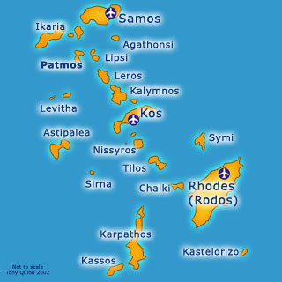The Dodecanese, which means ' the Twelve Islands' in Greek.

(Astypalea, Leros, Lipsi, Nisyros, Kalymnos, Karpathos, Kastellorizo, Kos, Patmos, Rhodes, and Tilos) which lie in a crescent chain down the Asiatic Turkish coast curving west towards Crete.

Most sailing companies and services are based on either Kos or Rhodes, being the two main islands in the chain. Rhodes sees thousands of visitors every year ans has much to offer sailors, whilst Kos generally, is the starting point for most sailing around the Dodecanese Islands.

Many of the Dodecanese islands, apart from Kos and Rhodes, are quite hard to reach (without a yacht) so are much quieter than elsewhere and the locals are most welcoming to visitors.

For those wanting a sailing trip in Greece that offers fantastic islands with a little more wind than the Ionian and the Saronic, the choice will probably come to down to the Sporades or the Dodecanese.

The Dodecanese is subject to the *meltemi* during the high season period with winds of F5-7 not unusual. More significantly, the islands are aligned broadly on the same direction as the prevailing NW winds so sooner or later you’re likely to be heading in to the wind.

**Samos** - is famous for its excellent wines, illustrated by the many vineyards that thrive on the fertile hills. It is geographically separated from Asia Minor by the Samos Strait which is just over one nautical mile wide.

There can be violent gusts near the south leeward coast. In the Samos Strait expect currents of 1-3 knots setting towards the east-south-east.

There are anchorages on all sides of the island, at Pithagorion, Kokkari, Karlovasi and Marathakambos.

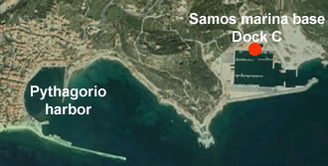**Samos Marina** is situated on a strategic location on the island of Samos, at the eastern Aegean Sea. The facilities are located on the southeast part of the island, just 500m away from the picturesque village of Pythagorio. Samos Marina provides mooring close to the village, but at an isolated and well-protected location for those who enjoy privacy. The marina is built in accordance with state of the art specifications and provides full range services to boats and boaters.

With a berthing capacity of 260 boats, Samos Marina can host yachts up to 25m in length according to the official plan. Super yachts up to 50m of length have been already hosted in the marina, and a number of at least 10 berths for yachts above 25m is arranged and adequately equipped. The marina boatyard can host up to 170 boats serviced all around the year at the repair and maintenance zone area.

**Patmos –** now an island under statutory protection as an ancient monument, where the acquisition of land by foreigners and the export of antiquities are prohi­bited. The 15th century monastery of St.John is worth a visit.

**Port Augusta** on the island of Arki is reached through a narrow inlet (10-5 m deep). Although the light on the north side of the entrance is easily identified a night approach is not advised since a reef extends from the north entrance (15 m long max).  
Anchor in the bend (6 m, mud) or take a line ashore next to the tavernas and enjoy the attractive surroundings.

**Leros and Kalymnos –** Leros is a hilly and fertile island with an abundance of water and a much-indented coast. Pserimos has a magnificent sandy beach to drop anchor at (just wait for the tripper boats to return to Kos). Kalymnos is a bare limestone island, separated from Leros, by the narrow channel of Stenon Lerou. The coasts are mostly steep and rocky, with numerous coves and inlets ideal for a sailing holiday.

Alinda bay is located at the east side of Leros and is easily located by the Venetian castle higher up. During *meltemi* strong gusts in the harbour. Seabed gives moderate/bad holding, so in strong winds move to the NW quay or sail to Pandali. The village of St Marina, where you find the **Ayia Marina**, is a very picturesque village with tranquil streets.

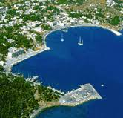**Port of Lakki** - Lakki is the largest natural harbour in Greece, almost resembling a lake with its tiny opening of just 400m.

The entrance of Ormos Lakki (Lakki bay) is only clearly visible looking NE. Once inside the bay Lakki town will be seen.  
In Lakki Marina mooring lines are to be picked up at the quay (engine in neutral!), but there are no actual mooring buoys floating. The harbour master will help you.

**Kalymnos Port** - located in the south of Kalymnos island.

**Vathi** – south of Kalymnos, is a deep (blue) inlet near the village of Rina. It has sand and weeds on the bottom with good holdings and a few simple provisions in the village.

**Kos** - The island of Kos is the second largest in the Dodecanese, the most fertile of the archipelago, tucked into the Gulf of Kos between the Myndus peninsula to the north and the Dorian promontory to the south. The harbour at Kos Town is guarded by an imposing castle of the Knights of St. John and there’s a likable mixture of medieval Frankish and Turkish architecture with some elegant Italian-built public buildings. The coastline of the island is dotted with some terrific beaches, attracting thousands of visitors every year.

**Kos Port** is located in a large shallow bay; in the approach the north cape should be kept at a distance. The west side inside the harbour is for charter yachts only. The east side - under the Castle of the Knights (1450-80) and matching palm trees - is the mooring area for visitors.

The bottom is mud with excellent holding, but it gets very crowded here in high summer. The new marina, lying just over a kilometer (3/4 mile) south east of the old harbour, is considered one of the best in Greece and a better option.

**Kos Marina –** (36˚ 53.5' N 27˚ 18.0' E)lies about 3/4 of a mile south east of the old harbour and the town of Kos. The approach and the entrance are straightforward. Call the marina on VHF and a RIB will escort you to a free berth. Berthing is stern/bow too with tailed moorings. The marina is a Port of Entry with Port Police on site and immigration and customs in the ferry terminal at the old port.

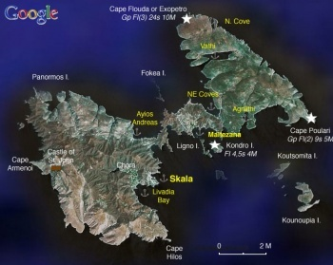

**Tilos** – with some unspolit beaches and just away from the crowds on Kos, it has a small port called Tilos Livadhi.

**Astypalea -** Astypalea, the most westerly of the Dodecanese. It has two wide bays on the north-west and south-east sides divide the island into a higher western half and a lower eastern half, joined by the Ayios Andreas Isthmus, which is only 110 m wide.

Skala is the main harbour, but there are several other well protected anchorages. However, they all suffer from the fierce gusts.

Skala or Perigialos is a safe harbour, but subject to violent gusts in a strong *meltemi*. A new breakwater extension provides secure berthing for around 6-8 yachts med moored to the quay. Water and electricity points are installed and have now been connected (June 2013). Diesel can be ordered by telephone via a small truck from the nearby gasoline station.

It is also possible to moor stern to or alongside the outer quay but it is sometimes crowded and close to the ferries and not at all protected from the *meltemi*. Alternatively, one or two yachts can anchor at the northern end of the bay, staying well clear of the anchors of yachts moored on the quay. Good holding in sand. The Hellenic Coast Guard is friendly, moderately helpful and their port fee is miniscule.

Alternatively, there is **Livadia Bay** (36°32.46′N, 26°20.7′E). This is a large sandy bay just 1.5 nm around the castle south of [Skala](http://www.cruiserswiki.org/wiki/Astypalea#Skala). It is much less susceptible to the gusts and very comfortable. Good holding.

**Maltezana Bay** (36°34.5′N, 26°23.2′E) The bay of Maltezana provides good shelter for N to SW winds, but it is somewhat exposed to the SE. There is a small quay and you may, if there is room, be able to moor at its edge. Otherwise anchor off-shore at 4 m, the bottom is sand and light weed, good holding. Also during the off season there are several moorings that one can use.

The island of **Symi** lies about 23 nm north-west of Rhodes and there are eight good harbours on the island. At the south of the island lies Sesklion island, with small coves and tranquil surroundings. In the north is the island of Nimos, which has a passage of 3.5 m minimum between the two.

The port of Symi is slightly sheltered from the wind by the tiny island of Nimos. Part of the port is allocated for the regular ferries that visit the island on a regular basis every afternoon, but once these leave, the sailing grounds are good.

**Rhodes** - the largest of the Dodecanese and the fourth largest Greek island (after Crete, Euboea and Lesbos), is a favourite port when visiting the south east of Greece and a very good starting point - much like Kos - for a sailing holiday in the Dodecanese. There are actually three cities and three harbours - modern, ancient and mediaeval.

Approaching Rhodes by yacht you get a first glimpse of the massive Old Town walls together with the graceful minarets and the arcaded waterfront markets with their exotic scents. The best place to moor your yacht is the **Mandraki harbour**, which features a tower with a bronze deer on top on either side of its entrance.

Mandraki harbour was the military port of ancient Rhodes, but nowadays you see millionaires' yachts, moored alongside quaint, old fishing boats is an unspoilt place, lined by seaside cafes. Mandraki is used by boats which leave here every day for short cruises to nearby islands and to bathing places on Rhodes. On the long breakwater front at Mandraki stand the three medieval windmills which ground the grain unloaded from merchant vessels in the harbour. The harbour is hopelessly crowded in the summer, with yachts often two or three out of the quay. Mandraki is now designated as a marina, although as yet few additional facilities have been introduced. Yachts can also go on the pontoon on the W side, just inside the entrance, if there is room.

**Rhodes Marina** – Greece’s newest, state of the art development, planned to be ready in early June 2015 at a cost of 100 million euros. Rhodes marina is located at the island of Rhodes next to the island’s Central Port and only 14 km away from the Rhodes International Airport. The marina features approximately 600 berths and accommodates a wide range of yachts from 30ft to 200ft and could host a boat up to 600ft. An extended fibber optic network provides each berth with TV, telephone, internet and remote control monitoring of electrical and water consumption. All the Marina Area is covered with wifi Internet. Security is provided through with the use of a CCTV system.  
Most of the docking area is also protected through an access control system. The entire Marina Area is also equipped with a public address system.

This new marina is expected to attract around 20,000 visitors per season.

**Crime Overview**

Traditionally, Greece was considered one of the safest destinations in Europe, with a low crime rate and a reputation for honesty. However, as the economic situation in the country has deteriorated over the last five years, so too have the crime rates. Many attribute this to the rising unemployment figures, especially with the youth market and the influx of immigrants from other countries fleeing war and poverty. With this in mind, it is worth treating Greece in the same way that you would any other European destination and as you would expect, crime in the capital Athens, is far more prevalent than on the many smaller islands spread throughout the Mediterranean.

On the mainland, in the capital Athens, petty crime, such as pick-pocketing and robbery are on the increase. Thefts are common on the city Metro system, carried out by sophisticated and well-practiced gangs of three to four people. The main line targeted, is the line that takes people from the airport towards the city centre. The gangs are on the look-out for newly arrived tourists, who look unfamiliar with their surroundings. The usual pick-pocketing gangs that use distraction techniques and robberies from victims using ATM machines, are no different from that of other European capitals. The same precautions should be taken from visitors, to avoid becoming a victim of such crimes. Don’t wear your valuables on your sleeve so to speak and avoid unlit or quiet areas where criminals would have no trouble robbing you without being seen. Appear confident when moving around and don’t make it obvious that you are a tourist new to the area. Avoid large gatherings. Athens has seen much more street protests in recent years, due to the economic slump and these can turn violent quickly, with the police responding in a heavy-handed way.

Drug crimes are also on the rise and penalties for those caught with drugs are very severe. If you are caught with drugs and they suspect you of being a trafficker, you can face up to life imprisonment. It can also take over a year before your case is heard, whilst you wait in a Greek jail.

Violent crimes are less common than in other European capitals, but they do occur. Targets of such crimes tend to be political figures, well-known public figures or wealthy industrialists.

Sexual assault crimes remain low in relation to population size, but the number of cases of child pornography appears to be increasing.

The number of traffic fatalities in Greece, is one of the highest per-capita in Europe. Human factors, poor road designs, and general disregard for safe driving practices result in hazardous conditions on roadways for both pedestrians and motorists. Motorcycles and scooters routinely drive between lanes and weave in and out of both moving and stopped traffic, posing significant risk to pedestrians. The massive infrastructure improvements and road construction projects completed prior to the 2004 Olympic Games alleviated some of the congestion in Athens, but a steady increase in the volume of traffic each year until the current economic crisis has decreased the positive impact of these improvements over time.  
Excessive speed, distracted driving (e.g. cell phone use), driving in the opposite direction, non-compliance with right of way, and drinking are major factors for accidents. Most accidents occur between 5:00 p.m. and 7:00 a.m., with accidents peaking during the summer months and the holiday season. The severity of injuries is exacerbated by widespread failure to use safety belts and motorcycle helmets. In addition, the ability to deliver emergency medical treatment immediately following accidents is poor; the response time to accident scenes in Athens is significantly slower than in the U.S. or other European cities. 

Active terrorist groups:

*Revolutionary Struggle*, which gained notoriety in 2007, after attacking the U.S Embassy with a rocket propelled grenade, are an anti-globalisation and anarchist movement, promoting anti-capitalist ideology. As the economic situation in Greece has deteriorated, the numbers involved in this movement has grown, especially with the young and disenfranchised. The group have been charged with assassinations of government officials and the bombings of police stations, banks and other representations of national interest.

*Conspiracy of Fire Nuclei* is an indigenous anarchist group that was designated as a terrorist organization in 2011. The group first appeared in 2008 in connection with a wave of firebombing attacks, but is most known for a series of package bombs in 2010 that targeted foreign embassies, diplomats, and European leaders. Statements from the group are particularly anti-capitalist. Members of Conspiracy of Fire Nuclei were arrested for armed robbery of a bank in northern Greece in February 2013.

In January 2013, a small IED exploded at a shopping mall in the Maroussi suburbs of Athens, supposedly planted by an unknown home-grown terrorist group, in an apparent politically motivated attack. In another similar attack, a bomb exploded in March 2013, outside a Greek ship owners house in a crowded pedestrian area, not far from the Acropolis.

In April 2014, a car bomb exploded outside the Bank of Greece, in the heart of Athens causing damage, but no injuries. Warnings are given to local newspapers and websites about the bombs prior to their detonation.

Many of these home-grown anarchist groups, such as the recently formed K*Vox are found in the bohemian Athens district of Exarchia, where cafes are used to promote and recruit potential activists. Recent attacks in Greece have been carried out by newly formed groups such as *Lovers of Lawlessness, Wild Freedom* and *Instigators of Social Explosion, Gangs of Consciousness, Lonely Wolf, the Untouchable Cell of Revenge* and most recently, *Untamed Desires,* all of whom target political figures or representatives of the judiciary and promote waging "urban guerrilla warfare" against the state.

On the other side of the coin, far right political groups are gaining in popularity, such as the Golden Dawn party, which has risen to as much as 14 percent in voting polls after winning support with free food hand-outs for Greeks and fierce anti-immigrant rhetoric. Attacks against immigrants, who are seen as a strain on the stretched economy of Greece, are on the increase.

Social media allows such groups to operate all across Greece, but most incidents to date are centred around the commercial capital, Athens. However, a recent case involving four young anarchists from middle-class families, when they attempted to rob a bank in the town of Velventos using AK-47’s, has brought the groups widespread support. The police brutality surrounding the case was well publicised in Greece and attempts by the police to hid the truth, by photo-shopping the pictures of the young men, has backfired on the authorities. More attacks like this are promised in the future.

Greek Islands have not been affected in the same way as the mainland, but sensible precautions are advised and as more visitors are encouraged to the islands, traditional customs and ways of life will undoubtedly change. Overall, however, the Greek islands are still considered to be the safest places in Europe.

**Arrival/Departure Procedures**

Arrival and departure procedures have changed in 2014. All yachts arriving from outside the EU, regardless of flag, may enter at any port with a port police office BUT are required to notify the port police in advance of their arrival (usually on VHF channel 12). Skippers are then required on arrival to present their documents and to complete a newly introduced form, the Pleasure Boat Document (PBD), and to carry it with them at all times. The PBD must be surrendered to the nearest port police office on leaving Greek waters. At present, a PBD does not appear to be required if arriving from another EU country, but this may be open to local interpretation. In addition, all arriving yachts need to pay the necessary cruising taxes and, if coming from outside the EU, clear customs and immigration.

A good quality Greek courtesy flag must be flown on entering Greek waters and, if arriving from outside the EU, a "Q" flag.

**Customs**

All yachts arriving from outside the EU will need to clear customs and immigration. Skippers must complete a customs declaration and any firearms and ammunitions MUST be declared on arrival.

Foreign registered yachts can buy fuel at duty-free prices. This must be arranged through Customs. Stations that sell fuel for foreign registered yachts are marked by blue and yellow diagonal stripes.

**Immigration**

A visa is not required for a visit of up to three months for citizens of the EU, Andorra, Antigua, Argentina, Australia, Canada, Ecuador, Iceland, Israel, Japan, Liechtenstein, Mexico, New Zealand, Nicaragua, Norway, St Kitts and Nevis, South Korea, San Marino, Switzerland, Taiwan, the USA and Zimbabwe. For longer stays a visa must be applied for well in advance of the 3 month expiry date.

Visas are not required for citizens of Brazil, Chile, and Uruguay for a maximum stay of up to two months, Hong Kong and Peru up to one month and Singapore up to two weeks.

Visas must be issued in advance for all other nationalities and are valid for up to three months, depending on nationality. Visa extensions can be obtained from the nearest police station or the Greece Aliens Department in Athens.

**Special Cruising Requirements/Documentation**

* Individual passports of all crew members are inspected on entry into Greece aboard a yacht, as is the case on departure with the same yacht. If leaving or arriving by other means (e.g. by air or ferry), documents will be inspected by Immigration at the point of arrival/exit and any visa (if required) date stamped.
* All non-EU yachts must clear in with the port police, Customs, Health, Immigration and Currency Control on arrival. The ship's papers - including detailed crew list - will be inspected by the port police and cruising tax levied as detailed below.
* EU-registered yachts need only report to the port police office at their first port of call with their documents and pay the cruising tax as detailed below. Proof of VAT payment may be required but in practice is rarely asked for.
* Yachts must carry their original registration documents and ship's radio station licence - one member of the crew must be in possession of a certificate to operate the radio/VHF
* The original insurance certificate and a Greek translation showing Third Party insurance with the amounts in figures need to be produced. These minimum amounts are:
  + 293,470 EURO liability for death or injury by sinking, collision or other cause for crew and third parties,
  + 146,753 EURO for damage,
  + 88,041 EURO for pollution.
* The skipper should have an International Certificate of Competence (although in practice this is rarely requested)
* For non-EU citizens, nights should be spent on board (not in hotels ashore, etc) - if not, the Harbour Master and the Immigration officer should be notified
* The registered yacht owner/skipper should be on board. If handing the boat's command to someone else, ensure that the proper documentation is obtained from the Port Police
* Fishing is only allowed with a snorkel in certain areas. Fishing with scuba gear is prohibited
* To protect archaeological sites, scuba diving is restricted - permission should be sought locally
* Chartering by foreign yachts is now allowed, but the vessel must be inspected and certificated according to Greek law, a process that involves a huge amount of red tape

**Fees and Charges**

**All Boats**:

* From 1 January 2014 all boats entering Greek waters are subject to a new cruising tax, irrespective of how long they stay. The tax is levied as follows: **Overall length 7m - 8m: €200; 8m – 10m: €300; 10m – 12m: €400; Over 12m: €100/metre.** There is a 30 per cent reduction for yachts permanently kept in Greece. For yachts over 12m, it is also possible to pay the tax on a monthly basis at a rate of €10 per metre. It appears that this new tax will replace all other current taxes, including the *Transit Log*, but until it is fully in force this is not absolutely certain.

**Transit Log**:

* For non-EU registered boats staying longer than 90 days, there was formerly a charge of 14.67 EURO per metre for the issue of a formal Transit *Log*. This charge was levied at the end of each 90 day period, but usually not if the yacht left Greece within 90 days. At present, it is envisaged that the *Transit Log* will be superseded by the new cruising tax and therefore, apart from customs and immigration clearance, the entry and circulation charges will be identical for EU and non-EU yachts.

**Other charges**:

* All public harbours charge a mooring or anchoring fee based on the tonnage and length of the yacht that is *usually* around €8 for an 11.0 metre yacht, payable to the port police. Boats from EU countries pay lower fees than those from non-EU countries, while Greek flagged boats pay even less. A debate is currently taking place in the Greek marine ministry as to whether the new cruising tax should replace these local payments entirely.
* If a boat is stored ashore a 'lift permission' is required, and a 'launch permission' to launch it. These are obtainable from the Port Police and cost a few euros - and some tax. Good boatyards will obtain these for you.

**Greece Visa and Passport Requirements**

|  | **Passport required** | **Return ticket required** | **Visa required** |
| --- | --- | --- | --- |
| Australian | Yes | Yes | No |
| British | Yes | No | No |
| Canadian | Yes | Yes | No |
| Other EU | 1 | No | No |
| USA | Yes | Yes | No |

**Passports****:**

A passport valid for three months beyond the length of stay and issued within the past 10 years is required by all nationals listed in the chart above except (**1**) EU nationals holding a passport or national ID card which is valid for the duration of stay.

If travelling from one border-free Schengen country to another however, EU nationals are not required to show a passport or national ID card. It is still recommended that you travel with your passport or ID card to prove your identity if necessary though. Note that Bulgaria, Croatia, Cyprus, Ireland, Romania and the UK are not part of the Schengen area, so a passport or ID card is required if travelling to/from these countries.

EU nationals are not required to possess a return ticket or show sufficient funds.

**Visas****:**

A visa is not required by all nationals referred to in the chart above for the following durations:

• Nationals of most EU countries for stays of up to 90 days (EU/EEA citizens may stay a further three months if seeking work).

• Nationals of Australia, Canada and the USA for stays of up to 90 days.

Nationals not referred to in the chart above are advised to contact the embassy to check visa

**Visa note****:**

Greece refuses admission and transit to holders of travel documents issued by the area of Cyprus not controlled by the Government of Cyprus, and holders of UN laissez-passers.

**Types and cost****:**

Transit/short-stay Schengen visa: €60 (£49.20).

Validity:

Schengen visa: 90 days within a six-month period.

**Health Advisory**

Greece vaccinations chart;

| **Title** | **Special precautions** |
| --- | --- |
| Diphtheria | No |
| Hepatitis A | Sometimes |
| Malaria | No |
| Rabies | No |
| Tetanus | Yes |
| Typhoid | No |
| Yellow Fever | No* |
|  | | |
| * A yellow fever vaccination certificate is required from all travellers over one year of age coming from infected areas. | | |

Members of the European Economic Area (EEA) and Switzerland are entitled to free emergency medical treatment providing they have a European Health Insurance Card (EHIC).

Visitors from outside the EU are strongly advised to take out travel medical insurance before visiting Greece. Respective consulates and Athens-based embassies can help visitors find hospitals and doctors in Greece, should the need arise. Note that most Greek doctors speak basic English. If you plan to do any ‘extreme’ sports, such as scuba diving whilst on holiday, you should also look into extra insurance cover.

For minor problems, it may be sufficient to visit a pharmacy – pharmacists in Greece are highly qualified and can offer advice and medication for mild conditions.

Emergency care, in the case of accidents, is provided free of charge to all nationalities at public hospitals. However, be aware that there is a certain degree of corruption within the Greek healthcare system. Even in public hospitals, doctors often expect under-the-table payments from patients in return for priority treatment, and sometimes receive kickbacks for referring patients to private institutions. Public hospitals are frequently understaffed, so it is not unusual for family members to bring patients meals from home and sometimes even stay overnight to help with basic nursing care. Private hospitals usually require the proof of adequate insurance or cash before admitting foreign patients.

Note that the Greek health care system is heavily concentrated in Athens (and to a lesser extent Thessaloniki), so that people from the islands and rural areas usually have to visit to the capital to see consultants and receive treatment for more serious ailments.

For emergencies, ring 166 (public ambulance).

Tap water is drinkable in Athens and other cities – in fact, in areas where the local water is good, bars and restaurants are obliged by law to provide customers with glasses or jugs of tap water free of charge upon request. So don’t be ashamed to ask. However, visitors should be wary of drinking tap water in remote areas, and on many islands – even if the locals do it, they have probably built up a resistance that newcomers may need time to acquire. Bottled water is widely available and prices are strictly controlled on the mainland and islands. Milk is pasteurised and dairy products are safe for consumption. Local meat, poultry, seafood, fruit and vegetables are considered safe to eat.

**Allmode Summary and Advice**

Just like in the previous two Mediterranean reports, this report can only be used as a guide and it has to be pointed out that tourism is one of the main industries for the Greek islands and therefore tries to protect the reputation of the islands. Like anywhere, it will have low levels of crime that can be avoided or diminished if sensible precautions are practiced. As tourists, sometimes people expose themselves to crime, by flaunting their cash or valuables in a way that attracts crimes. As stated in previous reports, don’t carry unnecessary amounts of cash and conceal it from view. On yachts, put away valuables from view of the quayside or marina and take sensible precautions such as removing the gang planks when not in use and securing doors that can be locked when not on the vessel.

Locals will tell you that crime rates rocket during the summer seasons, carried out by criminals visiting the islands, targeting tourists who leave their guard down. Tourists themselves are perpetrators of much of the crime in the islands. Greek people are notoriously laid back and friendly people.

The recent economic crisis that has hit much of Europe, has had its effect on Greece, but much of the protesting and riots that have occurred have been limited to the mainland, in and around Athens. Crime rates in Athens are rising, but island life stays very much the same. However, as more people visit the islands, crime will follow, as this is inevitable with crowds of people.

**Security Awareness Training**

**Are your crew compliant with the mandatory STCW 95 modules?**

STCW Regulation VI/6 became mandatory on 1st January 2014. This regulation requires all seafarers on ships subject to the ISPS Code to have received security related training and instruction relevant to their assigned duties on-board.

* **Proficiency in Security Awareness**

ALL seafarers who **do not** have specific security-related duties on board are required to hold a Proficiency in Security Awareness Certificate ([PSA](http://www.imsaltd.com/psa)) and will need to take an approved course approx. 4 hours in length.

* **Proficiency in Designated Security Duties**

All seafarers with **designated** security duties stipulated in the ship security plan will be required to hold a certificate of Proficiency in Designated Security Duties (PDSD) and will need to take an approved course approximately 10 hours in length.





**Allmode are currently one of the few accredited companies in the UK, who can offer the above courses.**

**For Full details of the courses on offer, please contact our office on:**

**+44 (0) 845 004 8000 or email us on** [**admin@allmode.org**](mailto:admin@allmode.org)

**Services**

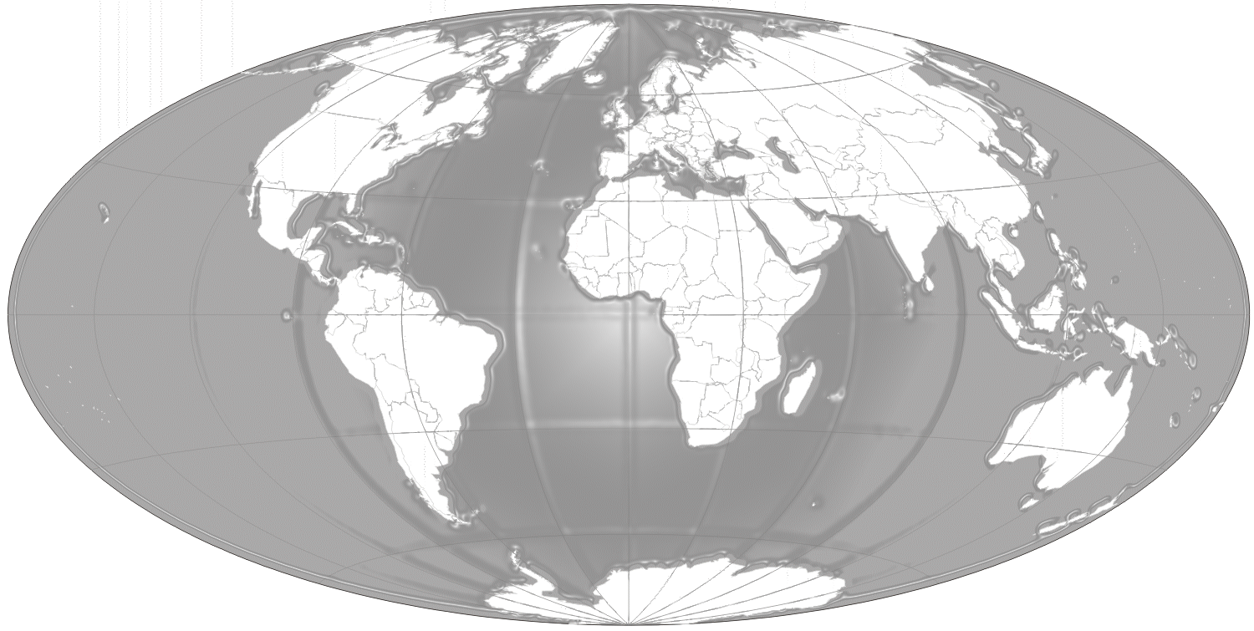

* **Hostile & Complex Environment**
* **Close Protection**
* **Maritime Security**
* **Intelligence Services**
* **Security & STCW Training Courses**

**FOR FURTHER INFORMATION ON SECURITY OR INTELLIGENCE PLEASE CONTACT**

General Enquiries: [info@allmode.org](mailto:info@allmode.org)

Phone: 0044 (0) 845 004 8000

Intelligence Support: [intelligence@allmode.org](mailto:intelligence@allmode.org)

Website: www.allmode.org

[twitter](https://twitter.com/allmodeLimited)[facebook](https://www.facebook.com/allmodeltd) **[](http://www.linkedin.com/company/allmode?trk=top_nav_home) [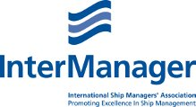](http://www.intermanager.org/)** 